Module 4

4.2 Assignment
Course: CSD325 – 340A
Prepared By: Mirach Erkol
Date of Report: 11/8/2025

Mikey5007/csd-325: csd-325

4.2 Assignment: Flow Chart #1
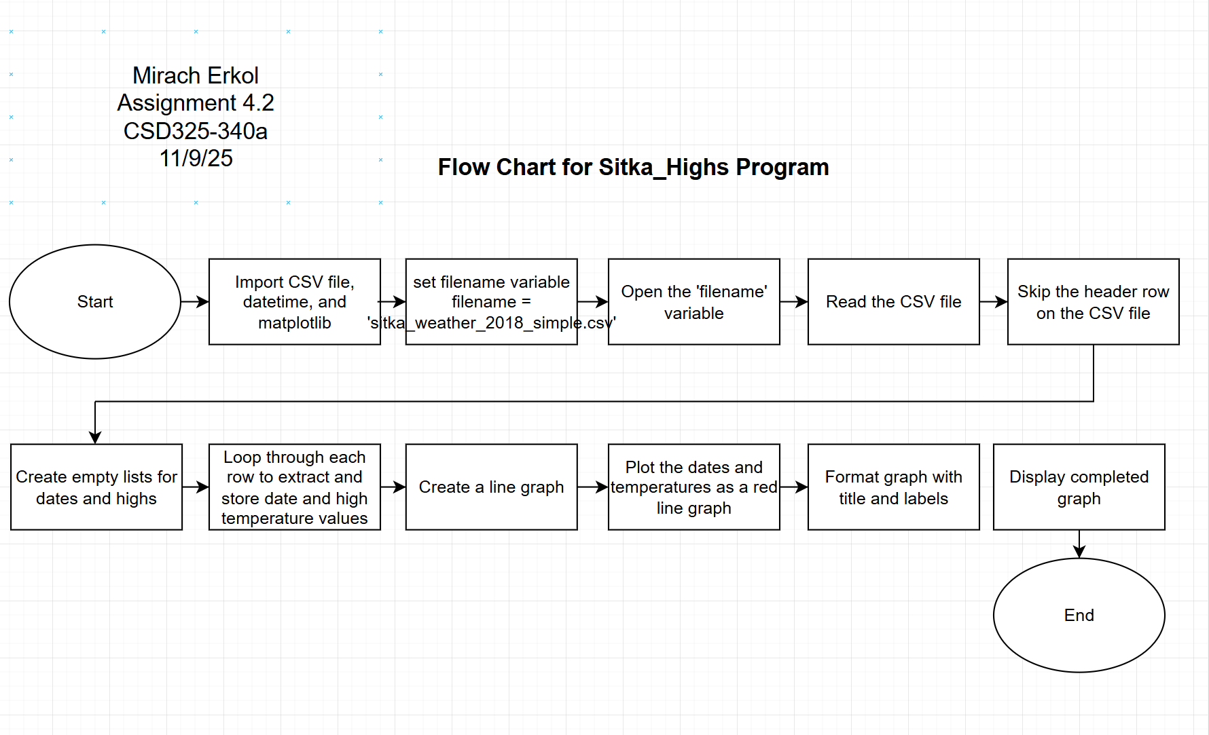

4.2 Assignment: Flow Chart #2
